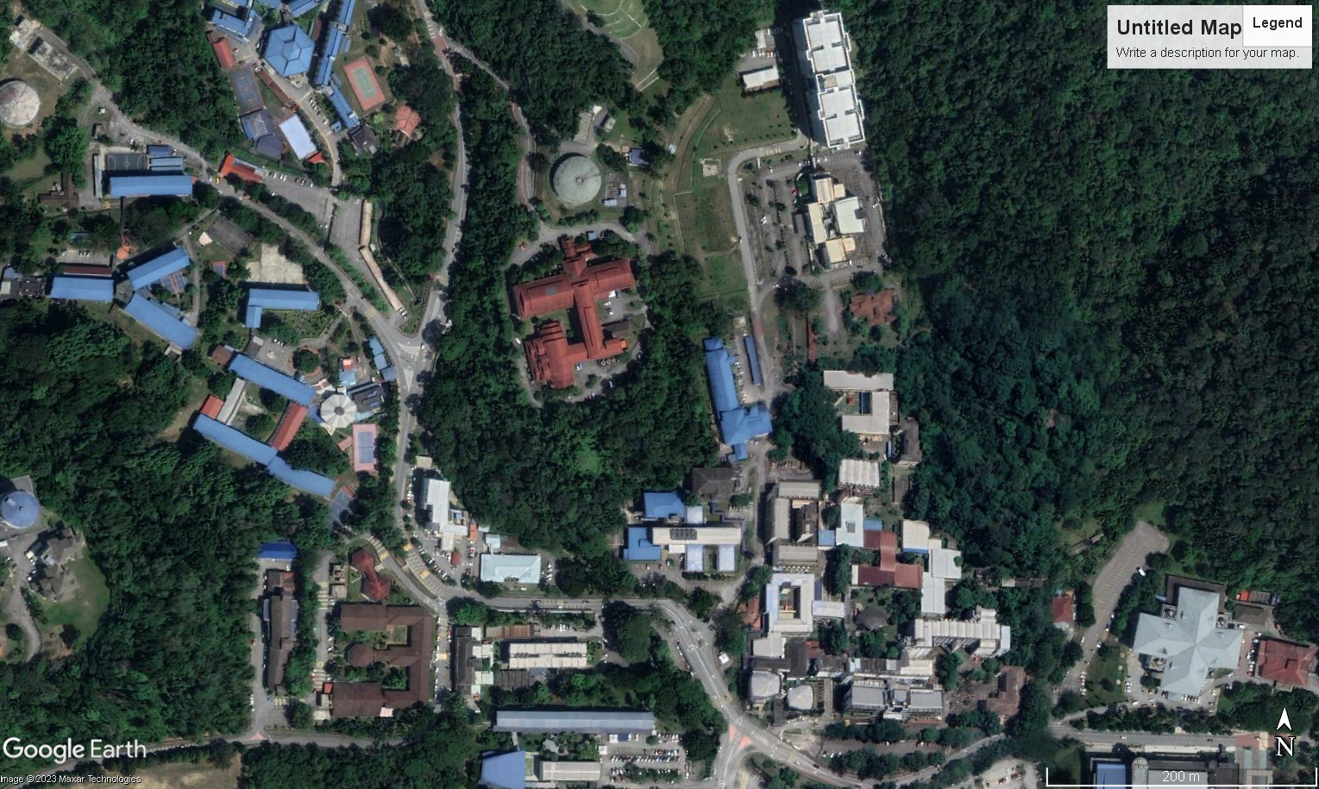

**Uncovering the Heat: A Study of Green Patch Areas in Faculty of Science, University Malaya**

SPG1

| Name | Matrics Number |
| --- | --- |
| Muhammad Alif Aiman Bin Abdul Malek | U2004961 |
| Nik Yuhanis Nerisya Binti Nik Yuzaine | 1720114 |
| Matdhesh Kummar a/l Jayaganthan | U2004879 |
| Muhammad Qhalis Yuuki Bin Azham Shah | 17206206 |
| Muhammad Azim Bin Ramlan | U2004716 |
| Muhammad Daniel Haikal Bin Halim | 17204036 |

**Key Concepts from Statistical Physics & Related fields**

∙ green patch ∙ entropy ∙ climate action ∙ SDG

## *“Destroying nature is destroying life. The loss of forests and green spaces not only fuels global warming, but it also robs of our very breath, our connection to the earth, and our hope for a sustainable future ”- Leonardo DiCaprio*

**Video Link**[**https://youtu.be/lcOEek14ypA**](https://youtu.be/lcOEek14ypA)

**Introduction**

Once upon a time, the Faculty of Science was a green oasis with trees, gardens and patches of grass. The students loved to stroll around, enjoying the cool shade of the trees and observing the many birds and animals that called the campus home. But, over time, things changed. The trees began to disappear, and the gardens were replaced with concrete walkways. The lush green patches started to vanish, leaving the students to walk around in the hot sun, uncomfortable and unproductive. This loss of greenery connects directly with Sustainable Development Goal 13, which strives to combat climate change and its effects. The increased temperatures are a clear indication of climate change, and the loss of biodiversity poses a threat to the ecosystem.To address this issue, we must encourage sustainable practices like planting trees, reducing carbon emissions, and preserving natural habitats. By doing so, we can ensure a greener, more sustainable future for ourselves and future generations.

**Data Analysis**

Shannon Entropy is a measure of information or uncertainty in data, used to quantify the amount of "surprise" or "unpredictability" in a set of information. In the context of studying green patches, it can be used to calculate the diversity and distribution of green areas within a given space, providing insights into the impact of green patches on climate change and their effectiveness in achieving sustainability goals. The higher the Shannon entropy, the bigger the information given by a new value in the process as it indicates an increase in the level of uncertainty or variability associated with a random variable while a decrease in Shannon entropy indicates a decrease in the level of uncertainty or variability. Shannon Entropy, often denoted as H, is calculated using the formula:

Where p represents the probability of occurrence of each unique value or category within the data set.

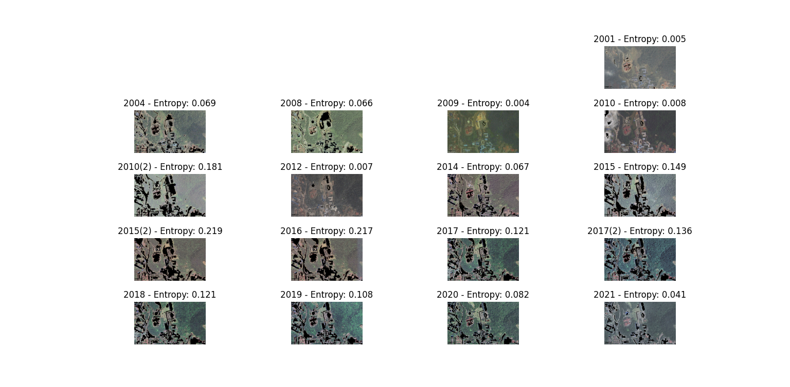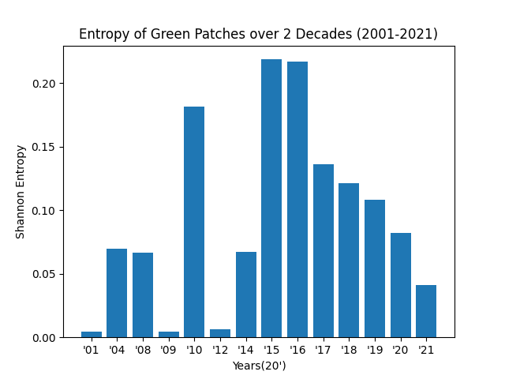

| *Figure 1: Image Entropy of Green Patches* | *Figure 2: Distribution of green patches entropy* |
| --- | --- |

Figure 1 provides a comprehensive view of the data representing the entropy values of green patches on the campus over a span of several years. The entropy values, which signify the diversity or randomness of the green patches, exhibit fluctuations over time. For instance, in 2001, the entropy value was measured at a relatively low level of 0.005, indicating a lack of diversity or randomness in the green patches. However, there were also years when entropy values showed slight fluctuations, such as in 2004 and 2008 when it rose to 0.069 and 0.066, suggesting a major increase in variability. But, then in 2009 , the entropy took a major decrease to 0.004 indicates the lack of variability. However, in 2015, there were two measurements with entropy values of 0.149 and 0.129, suggesting a substantial increase in the diversity of green patches on the campus. In contrast, in 2017, there were two measurements with entropy values of 0.121 and 0.136, indicating a decrease in diversity. In addition, it continues to decrease to 2020 and 2021 to 0.082 and 0.041 respectively. These findings highlight the dynamic nature of the green patches on the campus and the changes in diversity or randomness they undergo over time. It is worth noting that there are years where entropy values remained stable, such as in 2016 when it remained at 0.217, indicating a consistent level of diversity. From the Figure 2, we can see that the Shannon entropy is highest in the year of 2015 which is above 0.219 and the lowest in the year of 2001 which is below 0.005 This shows that the the uncertainty associated with the distribution with the green patches is highest in the 2015 and lowest in the year of 2001.

**Discussion & Conclusion**

The data presented in Figure 1 reveals interesting patterns in the entropy values of green patches on the campus over the years. For instance, in 2001, the relatively low entropy value of 0.005 suggests a limited diversity or randomness in the green patches, which could be indicative of a relatively homogeneous vegetation composition dominated by a few species. In contrast, in 2015, the substantial increase in entropy with values of 0.219 and 0.217 indicates a higher diversity or randomness in the green patches, potentially reflecting a more heterogeneous vegetation composition with a wider variety of plant species and habitats. However, compared with 2015, the entropy values have decreased over the years from 2017 until 2021, indicating a declining diversity or randomness in the green patches on our campus, which underscores the urgency of taking action to mitigate the impacts of global warming and protect our natural environment.

These examples highlight the fluctuations in the diversity and randomness of green patches on the campus, which can have implications for their resilience to climate change impacts. For example, higher entropy values may indicate a more resilient green patch ecosystem that can better adapt to changing environmental conditions, while lower entropy values may suggest a compromised ability to cope with such changes. In the context of SDG 13 - Climate Action, these findings underscore the importance of promoting and maintaining the diversity and resilience of green patches as part of broader climate change mitigation and adaptation efforts. Green patches with higher entropy values, indicating increased diversity and randomness, can contribute to climate change mitigation by sequestering more carbon dioxide, providing better habitat for biodiversity, and enhancing ecosystem services such as air and water purification. Furthermore, green patches with higher entropy values can also play a role in climate change adaptation by providing a buffer against extreme weather events, reducing urban heat island effect, and supporting greater ecological resilience to changing climatic conditions.

In conclusion, the study of green patches and their entropy values provides valuable insights into the dynamics of biodiversity and randomness of green spaces on the campus. The examples from the data highlight the importance of monitoring and managing green patches to promote their diversity and resilience, and ultimately contribute to climate change mitigation and adaptation efforts as part of SDG 13 - Climate Action. Further research, conservation measures, and sustainable management practices may be needed to safeguard the ecological integrity of green patches on the campus and support the achievement of SDG 13 in the context of climate change.